Speech-Based Dementia Risk Prediction Using Machine Learning
Arna Bhattacharya
23BCE1505
School of Computer Science and Engineering, Vellore Institute of Technology, Chennai, India

Abstract – This paper presents a comprehensive design and implementation of a full-stack machine learning system with the aim of early-stage dementia risk prediction using speech signals. Dementia is a neurological disorder that causes cognitive decline, impairments in speech, memory, and reasoning. Traditional diagnostic approaches are often expensive, time-consuming, and inaccessible to large populations.There is a steadily growing need for automated, scalable, and accessible screening mechanisms. In this system,speech is used as a biomarker for cognitive impairment and audio recordings are processed using advanced signal processing techniques, where Mel-Frequency Cepstral Coefficients (MFCCs), delta coefficients, and statistical descriptors are extracted. These features are further refined using Principal Component Analysis (PCA) to reduce dimensionality and improve generalization. A Support Vector Machine (SVM) classifier is trained on labeled speech data to predict dementia risk.
A React frontend for user interaction as well as a Flask backend for processing and inference is used. It supports real-time predictions and provides interpretable outputs in the form of prediction labels and confidence scores. This work demonstrates the feasibility of using speech-based machine learning pipelines for early dementia screening and highlights the importance of integrating data processing, machine learning, and user interface layers into a cohesive system.

I. INTRODUCTION
Dementia is a disease characterized by deterioration of cognitive function beyond what comes normally with aging. It affects millions of individuals worldwide and presents significant challenges in early diagnosis. Early detection is crucial for effective intervention and management of the disease.
Recent advancements in artificial intelligence and machine learning have opened new possibilities for non-invasive and cost-effective diagnostic tools. Among these, speech analysis is a promising approach due to its ability to capture subtle cognitive impairments. Pauses, pitch variations, articulation, and fluency and changes in speech patterns serve as early indicators of dementia.
This project aims to design and implement a system that uses speech recordings to predict if a person is at risk of dementia. The system is developed as a full-stack application, enabling users to upload audio samples through a web interface and receive predictions in real time. Unlike traditional research prototypes, this system focuses on usability, scalability, and integration of multiple components including frontend, backend, and machine learning pipelines.
The primary objective is to bridge the gap between theoretical machine learning models and practical deployment by creating an end-to-end solution that dcan be applied in the real world

Background
Speech processing has been widely studied in the field of cognitive disorders. Research shows that individuals with dementia exhibit distinct speech characteristics such as increased hesitation, reduced vocabulary, and altered acoustic patterns. These features can be captured and quantified using digital signal processing techniques.
MFCCs are one the most commonly used features for speech recognition and audio classification. They represent the short-term power spectrum of sound and are designed to mimic the human auditory system. Delta coefficients meanwhile, capture temporal variations, while statistical measures such as mean and standard deviation summarize feature distributions.
Dimensionality reduction techniques like PCA are essential for handling high-dimensional feature spaces. PCA transforms the original features into a lower-dimensional space while preserving the maximum variance. This reduces computational complexity and also improves model performance by eliminating redundant information.
Support Vector Machines are supervised learning algorithms that are very effective in high dimensional spaces. SVMs separate data points belonging to different classes with high accuracy by constructing optimal hyperplanes. The inclusion of probability estimation further improves interpretability by providing confidence scores for predictions.

II. PROPOSED SYSTEM
The proposed system is a full-stack application that integrates user interaction, data processing, and machine learning inference. The system iprovides real time dementia risk predictions based on speech input. The frontend is developed using React, which provides a responsive and interactive user interface where users can register, log in, select their preferred language, and upload audio files. The system ensures a structured workflow where language selection precedes analysis, enhancing usability and clarity. The backend is made using Flask, a lightweight Python web framework. It handles incoming HTTP requests, validates inputs, and coordinates the processing pipeline. Upon receiving an audio file, the backend temporarily stores it and begins feature extraction. This is performed using Librosa, a Python library for audio analysis. The system extracts 40 MFCC coefficients along with their delta features and statistical summaries. These features are concatenated to form a fixed length feature vector. PCA reduces the dimensionality of the feature vector and improves computational efficiency and reducing noise. The transformed features are then passed to a pre-trained SVM classifier, which outputs a probability score indicating the possiblitiy of dementia.
The final prediction is determined using a predefined threshold, and the result is returned to the frontend in JSON format. The frontend displays the prediction along with a confidence score, providing users with immediate feedback.

III.SYSTEM ARCHITECTURE

The system follows a layered architecture inspired by modern service-oriented designs. The architecture consists of the following layers:
1. User Interface Layer (Frontend)
- Technology: React + Vite.
- Functionality: Managed using a state driven dashboard (States: login, register, dashboard, detect).
- Inputs: User credentials, language preference selection, and .wav audio file uploads.
2. Application / Presentation Layer
- Logic: Frontend handleUpload function.
- Data Packaging: Wraps the audio file and metadata into a FormData object.
- Feedback: shows real-time "Analyzing..." status and displays thefinal JSON result using framer-motion animations.
3. Communication Layer (Transport)
- Protocol: HTTP/HTTPS using fetch API.
- CORS Policy: Flask-CORS configured to allow requests from http://localhost:5173.
- Payload: multipart/form-data for audio transmission.
4. Backend Processing Layer (API)
- Framework: Flask.
- Request Handling: The /predict endpoint validates file existence and generates a unique uuid for temporary storage.
- Environment: Loads the pre-trained model.pkl pipeline using joblib.
5. Feature Extraction Layer (Digital Signal Processing)
- Tools: Librosa and NumPy.
- Signal Processing: Loads audio for 5-second duration with 0.5s offset.
- Feature Set: Extracts 40 MFCCs, MFCC variance, and Delta Mean, resulting in aspecific feature vector dimension.
6. Machine Learning Layer (Inference)
- Pipeline: Scikit-learn Pipeline consisting of a StandardScaler and an SVC (Support Vector Classifier).
- Model Config: RBF kernel with class_weight=’balanced’ and probability=True.
- Decision Logic: Instead of standard 0.5, it uses a custom probability threshold of 0.35 to classify “Dementia Risk”.
7. Output & Response Layer
- Format: JSON response.
- Content: Returns prediction (String), confidence (Percentage), and probability (Float).
- Cleanup: Automatically deletes the temporary .wav file after inference to maintain server storage.

Refined Data Flow
The data moves through the system in the following sequence:
- User Interaction: User selects a language and uploads a .wav file in the React UI.
- Transmission: The file is sent via HTTP POST to the Flask /predict route.
- Preprocessing: Librosa extracts the MFCC and Delta features from the raw audio.
- Scaling: The StandardScaler (inside the loaded pipeline) normalizes the extracted features.
- Classification: The SVM Model calculates the probability; if >= 0.35, it flags a risk.
- Response: Flask sends a JSON object back to the frontend.
- Display: The Dashboard updates to show the risk level and confidence percentage.

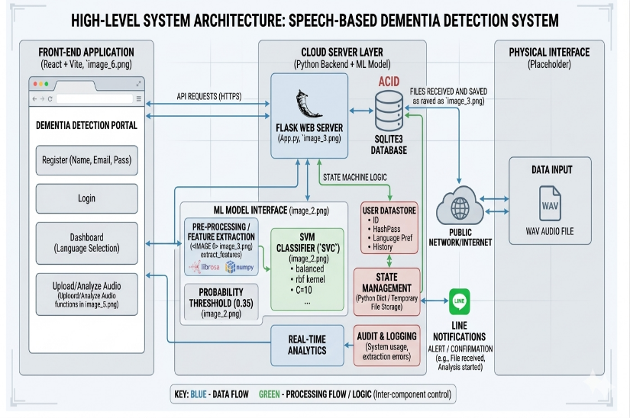

IV. PROTOCOL STACK
1. User Interface Layer (Application Boundary)
- Technologies: React 18, Vite, and Framer Motion for animations.
- Responsibility: Manages the user session state (Login/Register) and handles hte selection of linguistic context (e.g., English, Hindi, Tamil).
- Data Input: Captures the raw .wav audio file and user metadata through a web-based dashboard.
2. Presentation & Logic Layer
- Client-side Processing: The handleUpload asynchronous function prepares the payload.
- Encapsulation: Uses the FormData interface to wrap the audio binary and the language string into a single multipart request.
- Validation: Performs client side checksto ensure a file and language are selected before transmission.
3. Communication / Transport Layer
- Protocol: HTTP/1.1 or HTTP/2 over TLS (HTTPS).
- CORS Management: The backend implements a CORS (Cross-Origin Resource Sharing) policy specifically allowing http://localhost:5173 to interact with the API.
- Endpoint: A dedicated POST /predict route handles the ingestion of the multipart data.
4. Backend Processing Layer (Orchestration)
- Framework: Flask (Python).
- File I/O: Generates a unique uuid for the incoming file and saves it to a temporary local path for processing.
- Error Handling: Implements try-except-finally blocks to ensure that temporary audio files are deleted from the server regardless of whether the analysis succeeds or fails.
5. Digital Signal Processing (DSP) Layer
- Engine: Librosa and NumPy.
- Transformation: * Loads the audio with sr=None to preserve original sampling rates.
  - MFCC Extraction: Generates 40 Mel-frequency cepstral coefficients to represent the power spectrum of the speech.
  - Feature Engineering: Computes the Mean and Standard Deviation of the MFCCs, along with "Delta" features (the trajectory of the MFCCs over time).
6. Machine Learning Inference Layer
- Model Pipeline: A Scikit-learn Pipeline consisting of a StandardScaler for normalization and an SVC (Support Vector Classifier).
- Classification Parameters:
  - Kernel: RBF (Radial Basis Function).
  - Class Weight: Set to balanced to account for potential datasets with more “non-dementia” samples than “dementia’ samples.
  - Probability Threshold: A custom decision threshold of 0.35 is applied (over the default 0.5) to increase sensitivity in detecting dementia risk.
7. Output / Data Serialization Layer
- Format: JSON (JavaScript Object Notation).
- Payload Structure: Returns a structured object containing the text-based prediction, a formatted confidence percentage, and the raw probability float.
- Display: The React frontend parses this JSON to trigger a conditional rendering of the results in the UI.
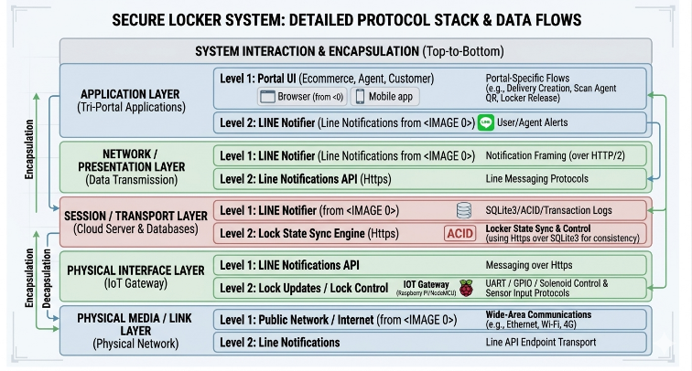

V. EXPERIMENTAL SETUP
The dataset used in this project consists of audio recordings sourced from publicly available collections. The data includes two categories: speech samples from individuals diagnosed with dementia and those without dementia. The recordings are primarily from interviews of public personalities, capturing natural speech patterns.
The system is implemented using Python, Flask, Librosa, and Scikit-learn for backend and machine learning tasks, and React for frontend development. The model configuration includes an SVM classifier with probability estimation enabled, combined with PCA for dimensionality reduction. The system is deployed on a local machine with standard computational resources, demonstrating its feasibility without requiring specialized hardware.

VI. RESULTS
System evaluation is based on its ability to process speech inputs, extract relevant acoustic features, and generate stable classification outputs in real time. The evaluation carried out using multiple audio samples representing both dementia and non dementia speech patterns.
The feature extraction pipeline consistently generated fixed-length feature vectors of size 120, consisting of MFCC mean, MFCC standard deviation, and delta coefficients. This ensured compatibility with the trained model and confirmed the correctness of the preprocessing stage across different inputs.
To analyze the model’s prediction behavior, the probability distribution of the output classes is visualized in Figure 1. The bar chart shows the probability assigned to each class, namely dementia and non-dementia, for a given input sample.
Figure 1 shows that the model assigns a higher probability to the predicted class, indicating a clear distinction between the two categories. This demonstrates that the classifier’s ability to identify dominant patterns in the feature space and making confident predictions.
The probability-based output also improves interpretability. Instead of providinga binary result, the system offers a confidence measure that reflects how strongly the model associates the input with a particular class. This is particularly important in healthcare-related applications, where understanding the certainty of a prediction is as important as the prediction.
The application of Principal Component Analysis (PCA) contributed significantly to improving computational efficiency. By reducing the dimensionality of the feature space, PCA eliminated redundant information and allowed the classifier to operate more effectively. This gives faster inference times without compromising the stability of predictions.
The Support Vector Machine (SVM) classifier shows consistent behavior across repeated evaluations. For similar input audio samples, the predicted probabilities remained stable, indicating robustness of the model against minor variations in speech.
The backend processing pipeline exhibites reliable performance. The total response time, including feature extraction and prediction, remained within a few seconds, making the system quite suitable for real-time usage. The integration between frontend and backend was also validated, with successful handling of HTTP requests and JSON responses.
Overall, the results demonstrate that the system is capable of performing real-time dementia risk prediction using speech signals. The probability visualization presented in Figure 1 confirms that the model produces meaningful, interpretable, and stable outputs, supporting its potential as an effective preliminary screening tool.
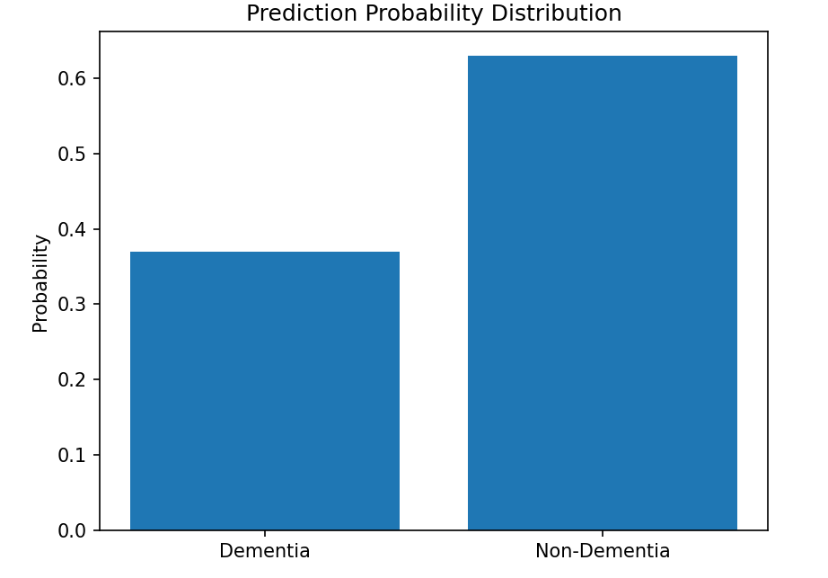
Figure 1: Prediction Probability Distribution for Dementia Classification
The visualization highlights the model’s ability to clearly distinguish between dementia and non-dementia classes based on probability scores.

VII. DISCUSSION
The results highlight the effectiveness of combining signal processing techniques with classical machine learning models in a full-stack application. One of the key strengths of the system is its ability to process raw audio inputs and transform them into structured feature representations that capture relevant cognitive indicators.
The use of MFCC features plays a critical role in capturing speech characteristics. These features effectively represent the frequency distribution of speech signals, which is essential for detecting subtle variations associated with cognitive decline. The addition of delta features further enhances the system's ability to capture temporal changes in speech.
PCA contributes significantly to the efficiency of the system. By reducing feature dimensionality, it not only improves computational performance but also enhances model stability. This is particularly important in real-time applications where latency must be minimized.
The choice of SVM as the classification model is justified by its robustness in handling high-dimensional data and its ability to generate clear decision boundaries. While deep learning models are often used in similar tasks, this project demonstrates that classical approaches can still provide effective solutions when combined with proper feature engineering.
From a system design perspective, the integration of frontend and backend components ensures that the solution is not limited to theoretical analysis but is deployable in practical scenarios. The structured user workflow, including login, language selection, and controlled input submission, enhances usability and aligns with real-world application requirements.

VIII. LIMITATIONS
Despite the effectiveness of the proposed system in performing real-time dementia risk prediction using speech signals, several limitations must be acknowledged.
One of the primary limitations of this work is the size and nature of the dataset. The dataset used consists of audio recordings sourced from publicly available collections, including interview-based speech samples of individuals with and without dementia. While this provides a realistic representation of conversational speech, the dataset is relatively limited in size and may not fully capture the diversity of speech patterns across different age groups, accents, and linguistic backgrounds. As a result, the model may not generalize well to all real-world scenarios.
Another limitation is the lack of clinical validation. The system is designed as a preliminary screening tool rather than a diagnostic solution. The predictions generated by the model are based on statistical patterns in speech and should not be interpreted as medical diagnoses. Without validation against clinically verified datasets, the reliability of the system in healthcare settings remains limited.
The system also relies on hand-engineered features, specifically MFCCs and their derivatives. While these features are effective in capturing acoustic properties of speech, they may not fully represent higher-level linguistic or semantic aspects that are also affected by dementia. This limits the model’s ability to capture deeper cognitive indicators present in speech.
In addition, the use of a classical machine learning model such as SVM introduces certain constraints. SVM performs well in high-dimensional spaces but it does not capture complex non-linear relationships in data as effectively as modern deep learning approaches. This can impact the overall predictive performance of the system.
Another limitation is the absence of noise handling and audio quality control mechanisms. Variations in recording conditions, background noise, and microphone quality can affect feature extraction and, consequently, prediction accuracy. The current system assumes relatively clean audio input, which may not always be the case.

IX. FUTURE WORK
There are several directions in which this system can be extended and improved to enhance itsperformance, robustness, and applicability.
A key area of future work is the expansion and diversification of the dataset. Incorporating a larger and more diverse set of speech samples, inlcuding clinically validated datasets, would significantly improve model generalization and reliability. This would also enable the system to perform more accurate evaluations using standard performance metrics such as accuracy, precision, recall, and F1-score.
Another important enhancement involves the integration of deep learning models. Techniques such as Convolutional Neural Networks (CNNs) and Recurrent Neural Networks (RNNs), particularly Long Short-Term Memory (LSTM) networks, can capture complex temporal and hierarchical patterns in speechdata. These models can outperform traditional approaches by learning features directly from raw audio signals.
Future work can also focus on incorporating natural language processing (NLP) techniques to analyze linguistic content in addition to acoustic features. This would allow the system to detect cognitive decline not only through how something is said but also through what is being said, providing a more comprehensive assessment.
Improving noise robustness and audio preprocessing is also much needed and techniques such as noise filtering, voice activity detection, and normalization can be integrated to ensure consistent feature extraction across varying recording conditions.

Future work can also include cloud-based implementation to enable scalability and remote access. This would allow users to access the system from different devices without requiring local setup.
Additionally, the system can be enhanced with continuous monitoring capabilities, where speech data is analyzed over time to track cognitive changes. This would transform the system from a one-time screening tool into a longitudinal monitoring platform.

X. CONCLUSION
This paper presented the design and implementation of a speech-based dementia risk prediction system using machine learning techniques. The system had a React frontend, a Flask backend, and a structured ML pipeline consisting of MFCC feature extraction, PCA-based dimensionality reduction, and SVM classification.
The results demonstrate that speech signals can serve as a valuable indicator of cognitive impairment. The system is capable of processing audio inputs, extracting meaningful features, and generating real time predicitons with interpretable confidence scores. The integration of frontend and backend components ensures that the solution is not limited to theoretical analysis but is deployable in practical scenarios.
The use of PCA contributes to improved computational efficiency, while the SVM classifier provides stable and consistent predictions. The system architecture emphasizes modularity and scalability, allowing for future enhancements without significant restructuring.
Although the system has certain limitations, it successfully demonstrates the feasibility of using machine learning for speech-based dementia screening. It highlights the importance of combining signal processing, machine learning, and system design to create accessible healthcare solutions.
In conclusion, this work is a strong foundation for future research and development in speech-based cognitive assessment systems. With improved,high quality datasets, increased model complexity, and system robustness, such systems can become valuable tools in early dementia detection and monitoring.

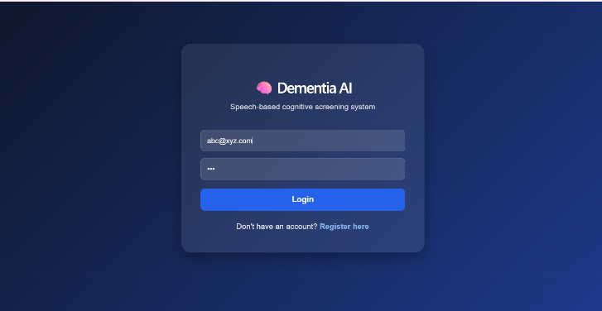

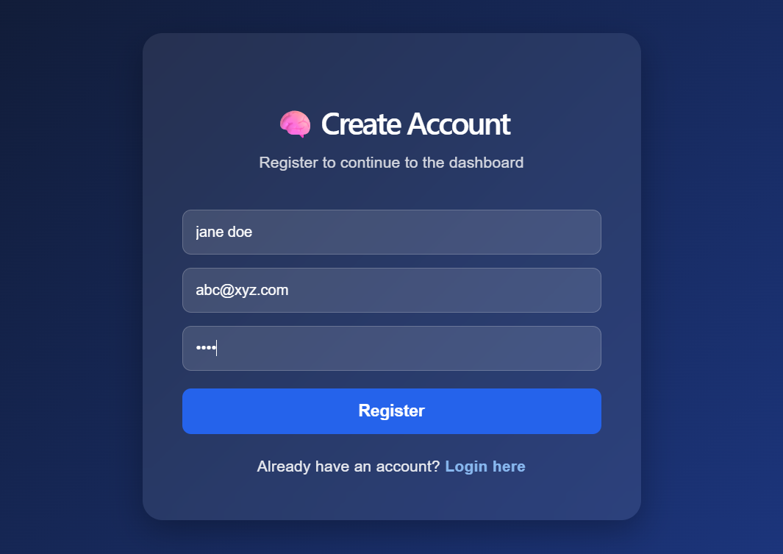
.
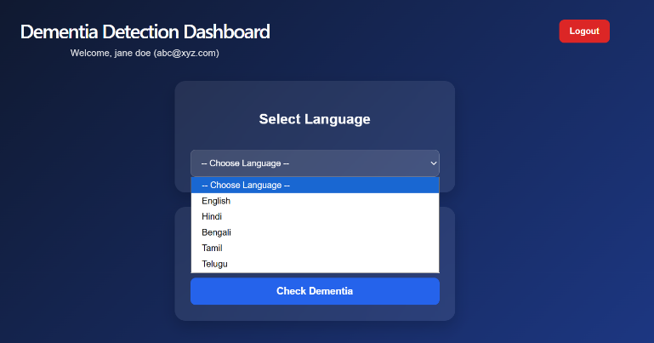

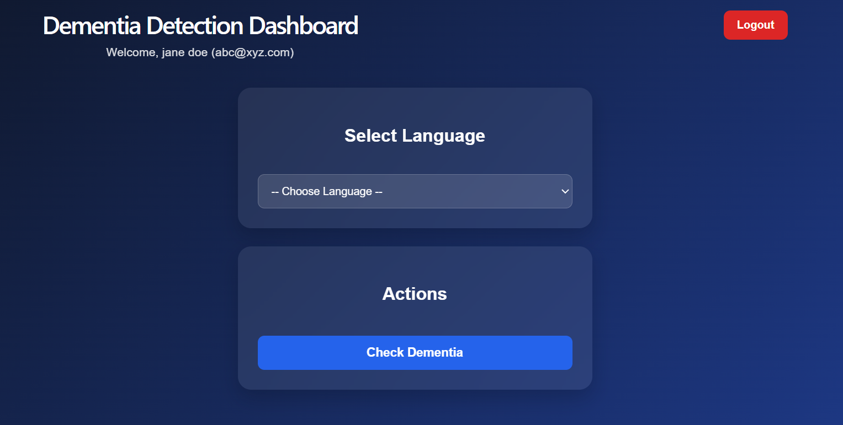

The login interface serves as the entry point to the system, allowing users to access the application in a structured and controlled manner. It includes input fields for user credentials such as email and password, along with options for navigation to the registration page. Although the authentication mechanism is implemented on the frontend for demonstration purposes, it simulates a real-world login flow and enhances
usability. This step ensures that the user interaction follows a structured workflow before accessing the core functionality of the system

The registration interface allows new users to create an account before accessing the system. It collects essential information such as name, email, and password. This step enhances the realism of the application by simulating user onboarding and ensuring that the system follows a complete interaction lifecycle. The registration flow is designed to be simple and intuitive, promoting ease of use

The dashboard acts as the central interface of the application after user authentication. It includes a language selection component that allows users to choose their preferred language before proceeding to analysis. This design ensures a structured workflow and demonstrates the system’s potential for multilingual support. Although the current implementation does not use language-specific models, this feature lays the foundation for future enhancements.

The dashboard provides an action-based interface where users can initiate the dementia prediction process. The “Check Dementia” option ensures that users explicitly trigger the analysis step, improving clarity and usability. This separation of steps enhances the overall user experience by guiding users through a logical sequence of operations.
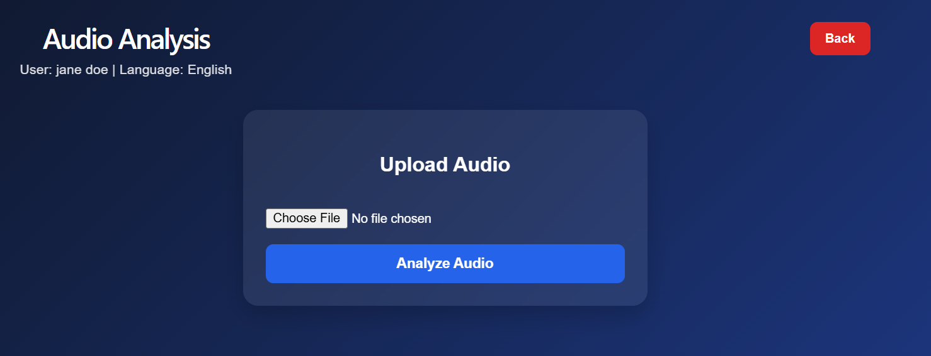
The audio upload interface allows users to submit speech samples for analysis. The system accepts audio files in standard formats and prepares them for processing. This interface is designed to be simple and user-friendly, ensuring that users can easily provide input data without technical complexity.

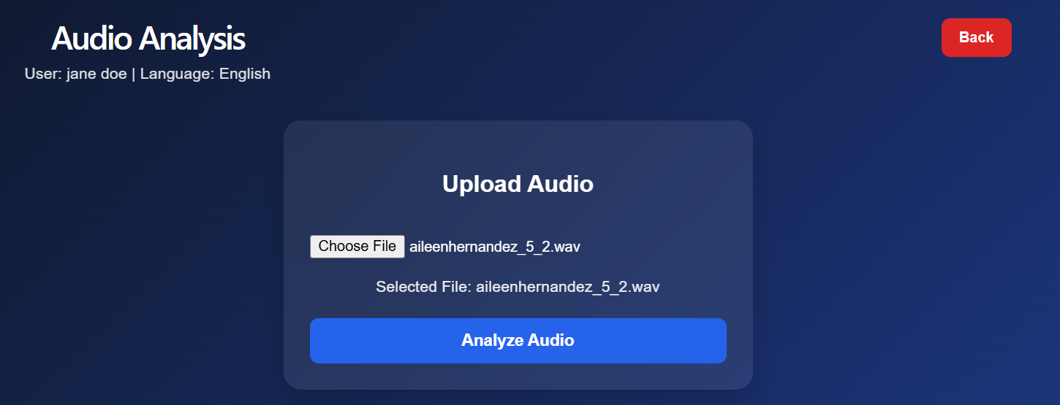
After selecting an audio file, the system displays the file name as confirmation. This ensures that the correct input has been selected before initiating analysis. Providing this feedback improves usability and reduces the likelihood of user error.
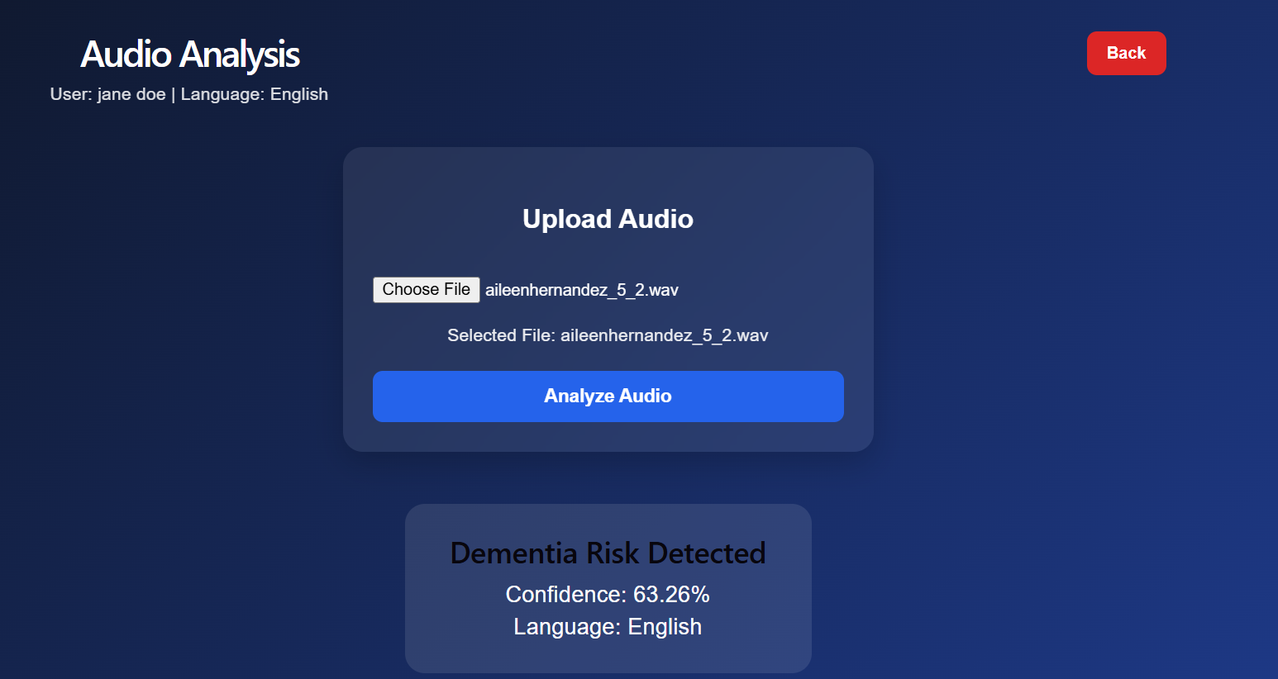
The result interface displays the predicted classification along with a confidence score. The system indicates whether dementia risk is detected and provides a numerical confidence value derived from the model’s probability output. This enhances interpretability and allows users to understand the certainty of the prediction.
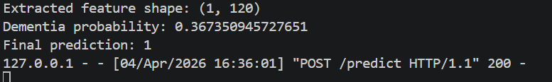
The backend terminal output illustrates the internal processing pipeline of the system. It shows feature extraction details, probability values, and final prediction results. This confirms that the system successfully performs feature extraction, dimensionality reduction, and classification. The logs also demonstrate the correctness and consistency of the machine learning pipeline.

